Information Booklet



"Bonding the World with Chemistry"

**49th INTERNATIONAL CHEMISTRY OLYMPIAD   
Nakhon Pathom, THAILAND**

**Constants and Formulae**

Avogadro's constant, *N*A = 6.0221×1023 mol–1

Boltzmann constant, *k*B = 1.3807×10–23 J K–1

Universal gas constant, *R =* 8.3145 J K–1 mol–1 **=** 0.08205 atm L K–1 mol–1

Speed of light, *c =* 2.9979×108 m s–1

Planck's constant, *h =* 6.6261×10–34 J s

Faraday constant, *F* = 9.64853399×104 C

Mass of electron, *me* = 9.10938215×10–31 kg

Standard pressure, *P* = 1 bar = 105 Pa

Atmospheric pressure, *P*atm = 1.01325×105 Pa = 760 mmHg = 760 torr

Zero of the Celsius scale, 273.15 K

1 picometer (pm) = 10–12 m; 1 Å = 10-10 m; nanometer (nm) *=* 10–9 m

1 eV = 1.6 × 10-19 J

1 amu = 1.66053904 × 10-27 kg

Ideal gas equation: *PV* = *nRT*

Enthalpy: *H* = *U* – *PV*

Gibbs free energy: *G* = *H* – *TS* 



Entropy change: , where *qrev* is heat for the reversible process

 (for isothermal expansion of an ideal gas)

Nernst equation: 

Energy of a photon:  Lambert-Beer law: 

Integrated rate law

Zero order First order 

Second order 

Arrhenius equation



**Periodic table of elements**

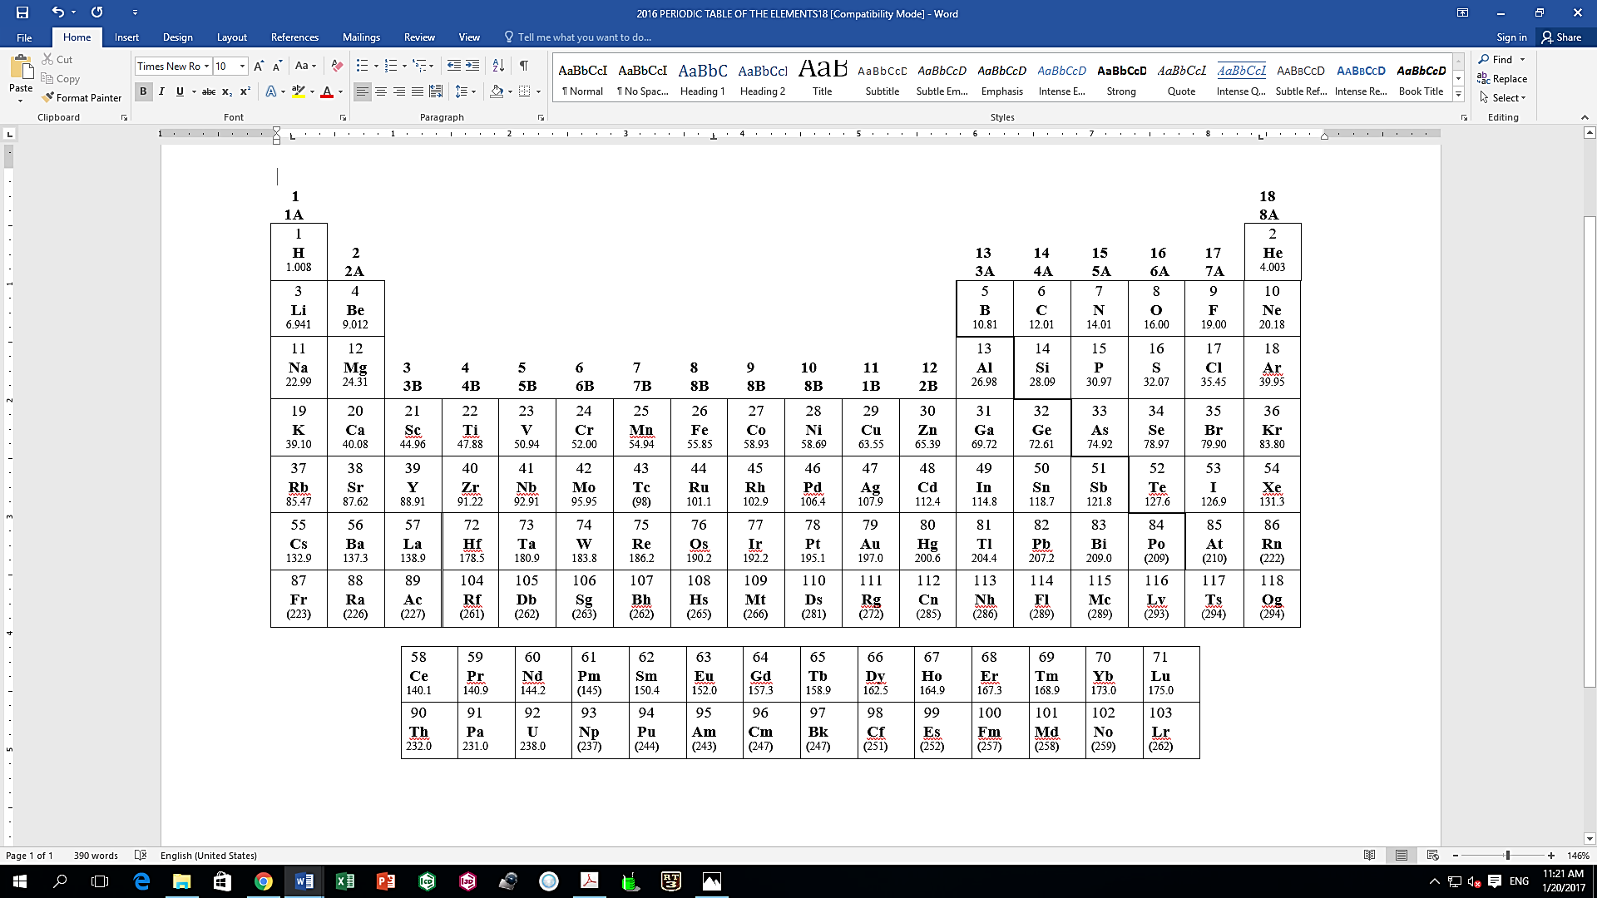

|  |  |  |  |  |
| --- | --- | --- | --- | --- |
| **Characteristic 1H NMR Chemical Shifts** | | | | |
| **Type of Hydrogen (R=Alkyl, Ar=Aryl)** | **Chemical Shift (ppm)** |  | **Type of Hydrogen (R=Alkyl, Ar=Aryl)** | **Chemical Shift (ppm)** |
| (CH3)4Si | 0 (by definition) |  |  |  |
| RC**H**3 | 0.9 |  | RC**H**=O | 9.5-10.1 |
| RC**H**2R | 1.2-1.4 |  | RCOO**H'** | 10-13 |
| R3C**H** | 1.4-1.7 |  | RCOC**H**3 | 2.1-2.3 |
| RC**H**2I | 3.2-3.3 |  | RCOC**H**2R | 2.2-2.6 |
| RC**H**2Br | 3.4-3.5 |  | RCOOC**H**3 | 3.7-3.9 |
| RC**H**2Cl | 3.6-3.8 |  | RCOOC**H**2R | 4.1-4.7 |
| RC**H**2F | 4.4-4.5 |  | R2C=CRC**H**R2 | 1.6-2.6 |
| RC**H**2NH2 | 2.3-2.9 |  | R2C=C**H**2 | 4.6-5.0 |
| RC**H**2OH | 3.4-4.0 |  | R2C=C**H**R | 5.0-5.7 |
| RC**H**2OR | 3.3-4.0 |  | RC≡C**H** | 2.0-3.0 |
| RC**H**2CH2OR | 1.5-1.6 |  | ArC**H**3 | 2.2-2.5 |
| R2N**H** | 0.5-5.0 |  | ArC**H**2R | 2.3-2.8 |
| RO**H** | 0.5-6.0 |  | Ar**H** | 6.5-8.5 |

|  |  |  |  |  |
| --- | --- | --- | --- | --- |
| **Characteristic 13C NMR Chemical Shifts** | | | | |
| **Type of Carbon (R=Alkyl, Ar=Aryl)** | **Chemical Shift (ppm)** |  | **Type of Carbon (R=Alkyl, Ar=Aryl)** | **Chemical Shift (ppm)** |
| R**C**H3 | 10-25 |  | R**C**(triplebond)CR | 65-85 |
| R**C**H2R | 20-35 |  | RCH=**C**HR | 120-140 |
| R3**C**H | 25-35 |  | Aryl**C** | 120-140 |
| R**C**H2COR | 35-50 |  | R**C**OOR | 160-180 |
| R**C**H2Br | 25-35 |  | R**C**ONR2 (amide) | 165-180 |
| R**C**H2Cl | 40-45 |  | R**C**OOH | 175-185 |
| R**C**H2NH2 | 30-65 |  | R**C**HO | 190-205 |
| R**C**H2OH | 60-70 |  | R**C**OR | 200-215 |
| R**C**H2OR | 65-70 |  |  |  |

*Adapted from RSC E-learning website.*

**IR Absorption Frequencies Table**

|  |  |  |  |
| --- | --- | --- | --- |
| **Characteristic IR Absorption Frequencies of Organic Functional Groups** | | | |
| **Functional Group** | **Type of Vibration** | **Characteristic Absorptions (cm-1)** | **Intensity** |
| **Alcohol** |  | | |
| O-H | (stretch, H-bonded) | 3200-3600 | strong, broad |
| O-H | (stretch, free) | 3500-3700 | strong, sharp |
| C-O | (stretch) | 1050-1150 | strong |
| **Alkane** |  | | |
| C-H | stretch | 2850-3000 | strong |
| -C-H | bending | 1350-1480 | variable |
| **Alkene** |  | | |
| =C-H | stretch | 3010-3100 | medium |
| =C-H | bending | 675-1000 | strong |
| C=C | stretch | 1620-1680 | variable |
| **Alkyl Halide** |  | | |
| C-F | stretch | 1000-1400 | strong |
| C-Cl | stretch | 600-800 | strong |
| C-Br | stretch | 500-600 | strong |
| C-I | stretch | 500 | strong |
| **Alkyne** |  | | |
| C-H | stretch | 3300 | strong, sharp |
| http://www2.ups.edu/faculty/hanson/Spectroscopy/IR/IRalkyne.gif | stretch | 2100-2260 | variable, not present in symmetrical alkynes |
| **Amine** |  | | |
| N-H | stretch | 3300-3500 | medium (primary amines have two bands; secondary have one band, often very weak) |
| C-N | stretch | 1080-1360 | medium-weak |
| N-H | bending | 1600 | medium |
| **Aromatic** |  | | |
| C-H | stretch | 3000-3100 | medium |
| C=C | stretch | 1400-1600 | medium-weak, multiple bands |
| Analysis of C-H out-of-plane bending can often distinguish substitution patterns | | | |
| **Carbonyl** |  | | |
| C=O | stretch | 1670-1820 | strong |
| (conjugation moves absorptions to lower wave numbers) | | | |
| **Ether** |  | | |
| C-O | stretch | 1000-1300 (1070-1150) | strong |
| **Nitrile** |  | | |
| CN | Stretch | 2210-2260 | medium |
| **Nitro** |  | | |
| N-O | stretch | 1515-1560 & 1345-1385 | strong, two bands |

|  |  |  |  |
| --- | --- | --- | --- |
| **IR Absorption Frequencies of Functional Groups Containing a Carbonyl (C=O)** | | | |
| **Functional Group** | **Type of Vibration** | **Characteristic Absorptions (cm-1)** | **Intensity** |
| **Carbonyl** |  | | |
| C=O | stretch | 1670-1820 | strong |
| (conjugation moves absorptions to lower wave numbers) | | | |
| **Acid** |  | | |
| C=O | stretch | 1700-1725 | strong |
| O-H | stretch | 2500-3300 | strong, very broad |
| C-O | stretch | 1210-1320 | strong |
| **Aldehyde** |  | | |
| C=O | stretch | 1740-1720 | strong |
| =C-H | stretch | 2820-2850 & 2720-2750 | medium, two peaks |
| **Amide** |  | | |
| C=O | stretch | 1640-1690 | strong |
| N-H | stretch | 3100-3500 | unsubstituted have two bands |
| N-H | bending | 1550-1640 |  |
| **Anhydride** |  | | |
| C=O | stretch | 1800-1830 & 1740-1775 | two bands |
| **Ester** |  | | |
| C=O | stretch | 1735-1750 | strong |
| C-O | stretch | 1000-1300 | two bands or more |
| **Ketone** |  | | |
| acyclic | stretch | 1705-1725 | strong |
| cyclic | stretch | 3-membered - 1850 4-membered - 1780 5-membered - 1745 6-membered - 1715 7-membered - 1705 | strong |
| ,-unsaturated | stretch | 1665-1685 | strong |
| aryl ketone | stretch | 1680-1700 | strong |

*Data from* [*http://www2.ups.edu/faculty/hanson/Spectroscopy/IR/IRfrequencies.html*](http://www2.ups.edu/faculty/hanson/Spectroscopy/IR/IRfrequencies.html)